CNN-Driven Voice Guidance: Image Based Medicine Recognition

Aruna Bharathi Jadam (218W1A0519) , Divya Durgempudi (218W1A0512)

Guide: S. Ravi Kishan, Associate Professor

Department of Computer Science and Engineering

Velagapudi Ramakrishna Siddhartha Engineering College, Kanuru

**Abstract**

There are many benefits of using image processing to identify medications. It increases access to important medical information outside of the boundaries of formal education. By taking pictures of packaging sheets, anyone regardless of educational background, may quickly identify medications using a straightforward image-based interface. This easy-to-use method yields fast and precise results while drastically cutting down on the amount of time spent looking for information. It encourages safety and well-informed decision-making by giving consumers the ability to confirm the purposes of medications, so reducing the dangers associated with inadequate pharmaceutical understanding. Moreover, the system’s integration of speech output capabilities guarantees that users receive audio-based information regarding the detected medicine, irrespective of their reading level or visual disability. This flexible and affordable solution has the ability to help people with disabilities and a variety of other groups. It also provides improved accessibility and fosters a more welcoming and safe environment for the use of medications. In summary, the utilization of image processing in drug identification not only guarantees dependability and precision but also makes a substantial contribution to the promotion of knowledgeable and easily accessible healthcare practices.

# Problem Statement



A significant challenge has been identified concerning the proper utilization of medication, particularly among uneducated individuals and the elderly. Many of these individuals struggle to understand and remember the correct dosages, timings, and purposes of the medications they are prescribed. This lack of medication literacy and adherence has led to recurring health issues and increased healthcare costs. The problem is exacerbated by a lack of access to clear, understandable information about medications, as well as inadequate support systems for these population.

# Architecture



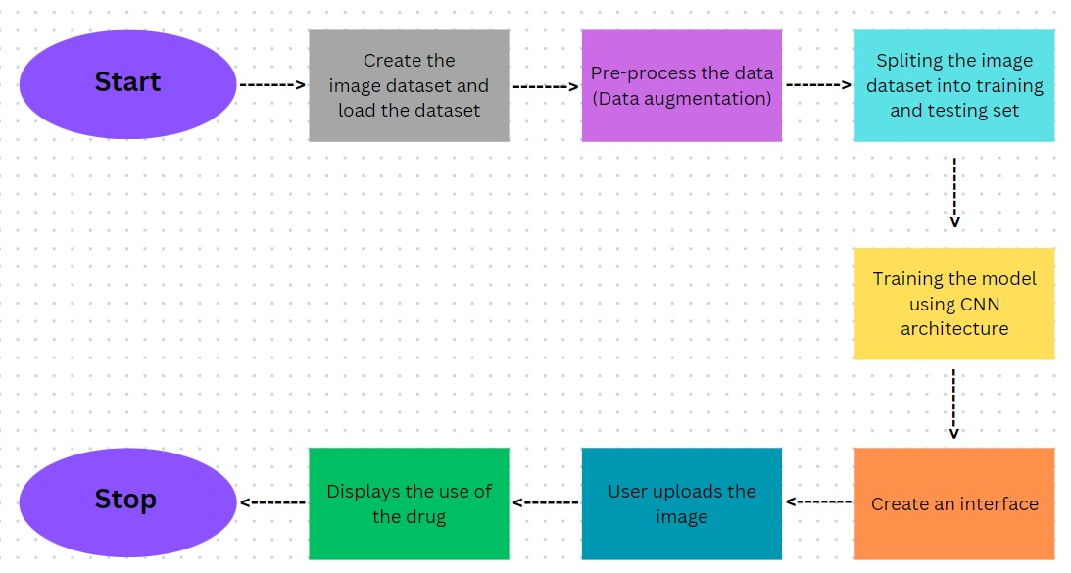

Figure 1:Proposed Architecture

# Results



.

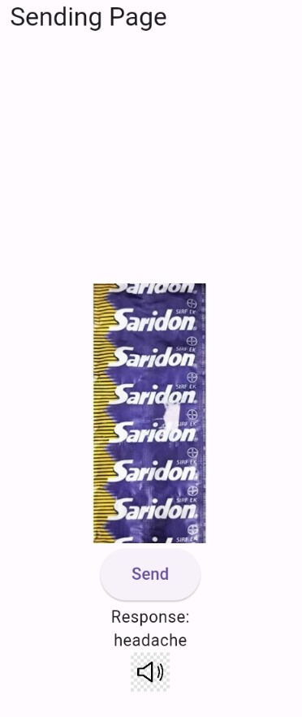

Figure 2:Medicine Use display

Below Figure shows the different pages and navigations available in the app.

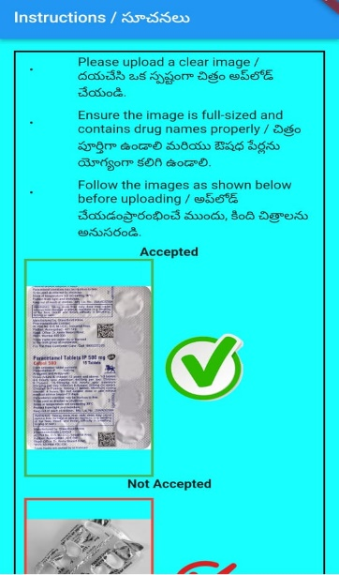 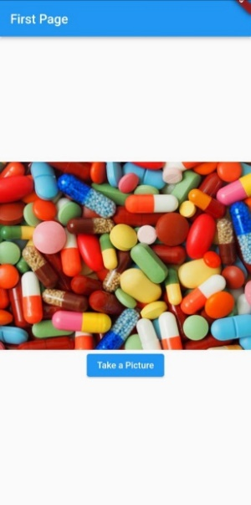

Figure 3:Instruction page

# Results



Below graph shows the prediction of the medicine class by CNN model..

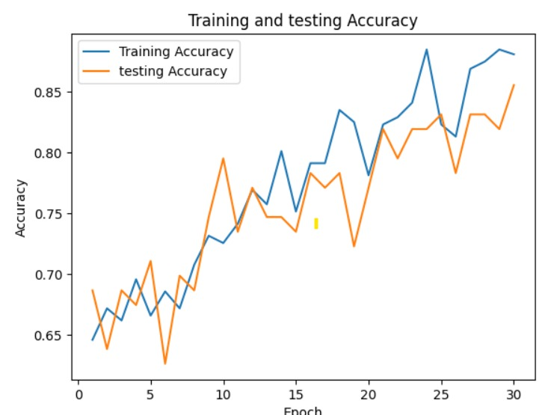

Figure 4:Graph between training and testing

Below figure shows the how accurately the model classifying the medical image.

Figure 5:Accuracy details

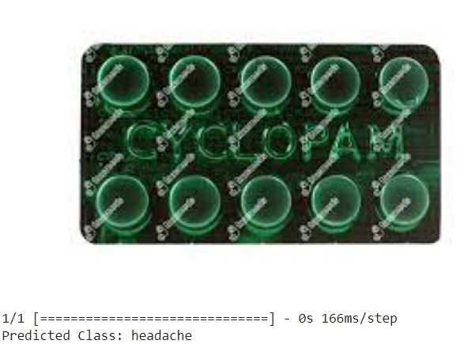



Figure 6:Medicine use prediction

# 

# Conclusion & Future Work



In conclusion, identification of drug and facilitating the users to know about its uses in their native languages will become more useful to users. By this application learners will be beneficial and it is for uneducated people so our application if easy to use and giving effective results. This will reduce the side effects and harmful drug interactions by establishing awareness among the people. It will result in healthy state of users and make them aware of medicines and our future work is to provide the app in a regional

Language.

# References



* Alzubaidi, L., Zhang, J., Humaidi, A.J. et al. Review of deep learning: concepts, CNN architectures, challenges, applications, future directions. J Big Data 8, 53 (2021). https://doi.org/10.1186/s40537-021-00444-8
* Paul D, Sanap G, Shenoy S, Kalyane D, Kalia K, Tekade RK. Artificial intelligence in drug discovery and development. Drug Discov Today. 2021 Jan;26(1):80-93. doi: 10.1016/j.drudis.2020.10.010. Epub 2020 Oct 21. PMID: 33099022; PMCID: PMC7577280.

**Contact Information**

* [arunajadham2021@gmail.com](mailto:arunajadham2021@gmail.com)
* [durgempudidivya1508@gmail.com](mailto:durgempudidivya1508@gmail.com)